USE CASES DOCUMENT

GeneConnect

DOCUMENT REVISION HISTORY
Version Number | Date | Description
0.1 | Mar 2006 | Initial Draft (Arun Venkatesan)
0.2 | Apr 5, 2006 | Edits and comments (R. Freimuth)
0.3 | Apr 6, 2006 | Added details for Query Interface use cases + API + (Arun Venkatesan)
0.4 | Apr 7, 2006 | Edits and comments (R. Freimuth)
0.5 | Apr 12, 2006 | Edits and comments (Munesh Gupta)
0.6 | Apr 13, 2006 | Use case diagrams modifications (Arun Venkatesan)
0.7 | Apr 13, 2006 | Edits and comments (R. Freimuth)
0.8 | May 31, 2006 | Edits and comments (R. Freimuth)
1.0 | June 5, 2006 | Draft Use Case Document finalized
1.1 | July 10, 2006 | Final Use Case Document (A. Venkatesan and R. Nagarajan)
1.2 | August 8, 2006 | Addressed adopter and reviewer comments (R. Nagarajan)
1.3 | August 9, 2006 | Approved by adopters and VCDE and ARCH reviewers

Table of Contents

USE CASES DOCUMENT 1
GeneConnect 1
1 Introduction 3
1.1 Background/Summary 3
1.2 Related Documents 3
1.3 Definitions 3
2 Actors and Goals 7
2.1 Administrator 7
2.2 Public User 7
2.3 Application Developer 7
2.4 System 7
3 Use Cases 8
3.1 Use cases Model diagram 8
3.2 Create the GeneConnect database schema 10
3.3 Create Configuration file 10
3.4 Download data from a data source 10
3.5 Parse data files and generate pair-wise links between identifiers 11
3.6 Generate the set of genomic identifiers for all data sources and ONTs (Orders of Node Traversal) 11
3.7 API Level Use Cases 12
3.7.1 Links to other genomic identifiers given one or more genomic identifiers for a single genetic locus 12
3.7.2 Links to other genomic identifiers given one or more genomic identifiers for more than one genetic locus 12
3.8 caGrid Level Use Cases 13
3.8.1 Links to other genomic identifiers given one or more genomic identifiers for a single genetic locus 13
3.8.2 Links to other genomic identifiers given one or more genomic identifiers for more than one genetic locus 14
3.9 Web-based Query Interface Use Cases 15
3.9.1 Links to other genomic identifiers given one or more genomic identifiers for a single genetic locus 15
3.9.2 Links to other genomic identifiers given one or more genomic identifiers for more than one genetic locus 15
4 Approval 17

Introduction

Background/Summary
The NCI caBIG™ project is creating a common, extensible informatics platform that integrates diverse data types and supports interoperable analytic tools. This platform will allow research groups to tap into the rich collection of emerging cancer research data while supporting their individual investigations. However, it is very likely that joins cannot be performed across many developer projects because they will use non-overlapping sets of genomic identifiers in their object models. For example, while the Function Express project may use the Entrez Gene ID to reference genes, the Cancer Molecular Pages project may employ the Ensembl Gene ID to reference genes.
GeneConnect is the mapping service that will facilitate interoperability by interlinking VCDE approved genomic identifiers (http://gforge.nci.nih.gov/frs/?group_id=108 and https://cabig.nci.nih.gov/workspaces/VCDE/Data_Standards/GeneIdentifier.zip) These include:

- Ensembl Gene ID
- Ensembl Transcript ID
- Ensembl Protein ID
- Entrez Gene ID
- UniGene ID
- GenBank mRNA Accession Number
- GenBank Protein Accession Number
- RefSeq mRNA Accession Number
- RefSeq Protein Accession Number
- UniProtKB Primary Accession Number

To interlink all of these identifiers, database annotations will be used to construct pair wise connections, and then all-to-all relationships will be calculated by traversing all possible combinations of edges in the graph using every node as the starting point. Next, using reciprocality calculations performed over the data sources, the set of non-commutable results will be determined with each record given a confidence score based on the ratio of commutable results (i.e. all the graphs whose identifier at each position is identical) to all possible combinations for set of the genomic identifiers under question.

Related Documents
None

Definitions
- Direct Annotation: When genomic identifiers in a data source contain ‘links’ to genomic identifiers in another data source, this relationship is termed as Direct Annotation. For instance, Entrez Gene contains links to Unigene and hence there exists a Direct Annotation between the two.
- Inferred Annotation: When genomic identifiers in a data source do not contain direct links to genomic identifiers in another data source, but whose relationship with the second data source can be ‘inferred’ based on the direct annotation link between the second data source and the first data source, this relationship is termed as Inferred Annotation. For instance, no direct annotation link exists between RefSeq mRNA and Ensembl Transcript; however a direct annotation link exists between Ensembl Transcript and RefSeq mRNA. Thus, RefSeq mRNA has an inferred annotation link to Ensembl Transcript.
- Exact Match: When a genomic sequence from a data source is compared to a second genomic identifier from another data source and the comparison results in an exact match (the sequences are identical), this relationship is called an exact match.
- Inexact Match: When a genomic sequence from a data source is compared to a second genomic identifier from another data source, and the comparison results in sequence similarity but NOT sequence identity, this relationship is called an exact match.
- Sequence Alignment: A way of arranging DNA, RNA, or protein primary sequences to emphasize their regions of similarity, which may indicate functional or evolutionary relationships between the genes or proteins in the query (From http://en.wikipedia.org/wiki/Sequence_alignment).

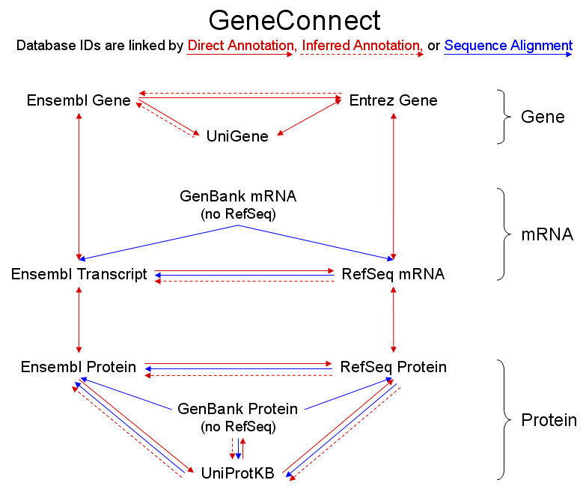
Figure 1. An illustration of the data sources used by GeneConnect and the method(s) by which identifiers from one data source are linked to identifiers from another data source.

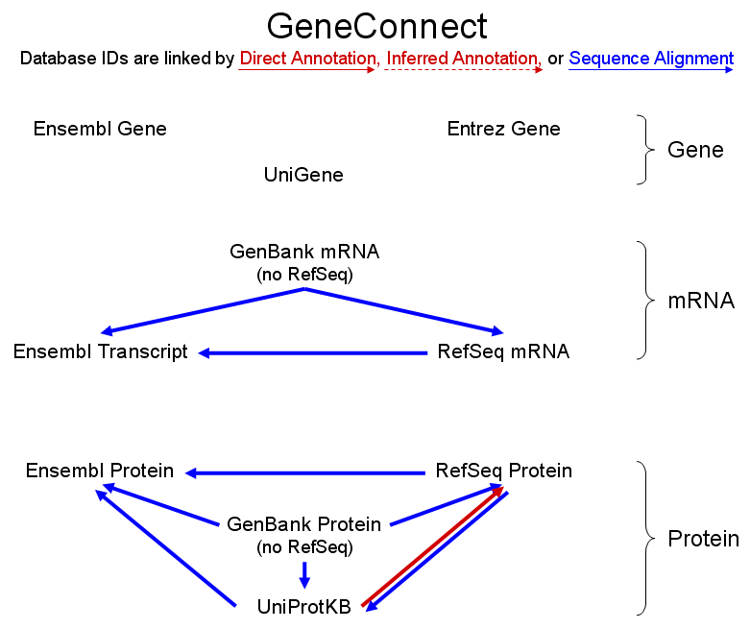

Figure 2. A simplified illustration of the data sources used by GeneConnect and the method(s) by which identifiers from one data source are linked to identifiers from another data source. Lines indicate links where both exact and inexact matches are possible. Links that contain only exact matches were omitted from the figure for simplicity.

Actors and Goals

Administrator
An Administrator is the person who runs GeneConnect in all modes, i.e. creating the database schema and updating the annotations database at regular intervals.

Public User
A public user can access the web pages to query the database to determine mappings between different genomic identifiers. This user type does not require authentication, since anyone accessing the web pages has the ability to perform the query operations.

Application Developer
Application Developers can use the APIs to programmatically query the GeneConnect database.

System
Any operations performed internally by the GeneConnect server are described as being performed by the System actor.

Use Cases

Use cases Model diagram
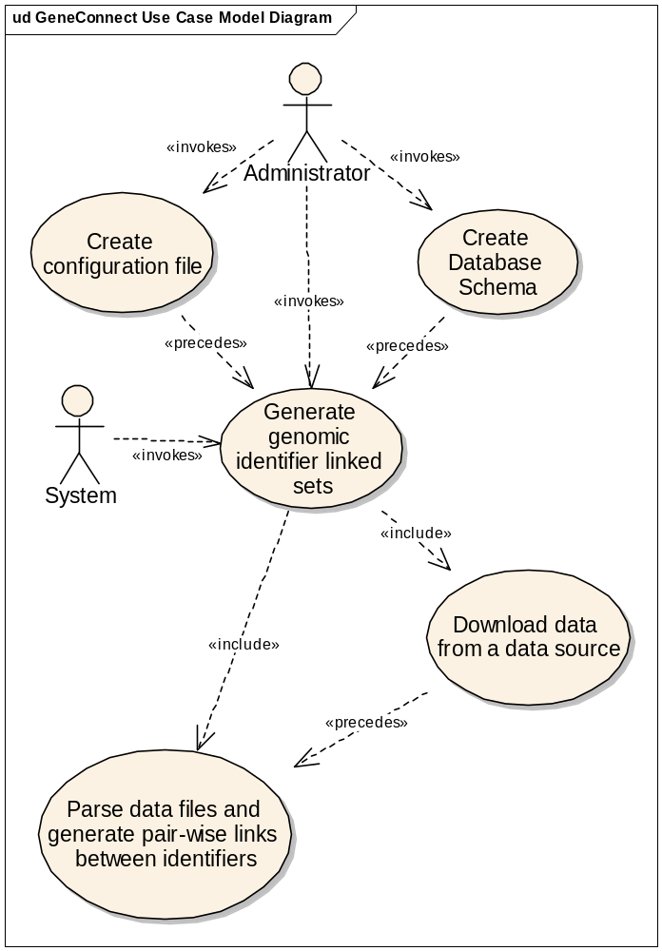

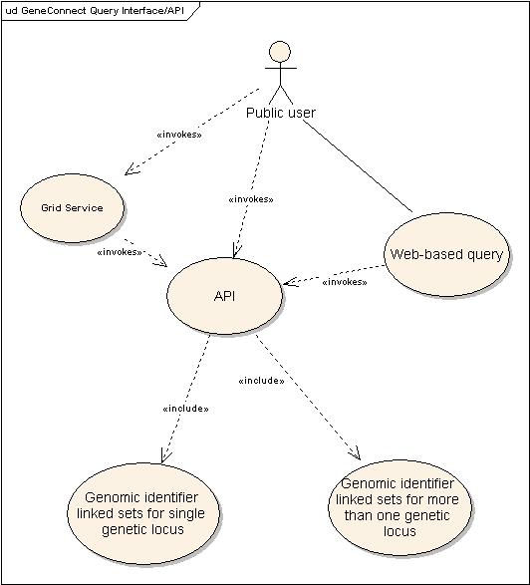

Create the GeneConnect database schema
Use Case Name | Create the GeneConnect database schema
Actors | Administrator
Goal | Create the GeneConnect database schema
Pre-Conditions | - The GeneConnect database instance is created, while the schema is not yet created.  - Administrator configures GeneConnect Server with the following information:  - GeneConnect database server name and port  - GeneConnect database user name and password  - Set GeneConnect mode to Schema Creation
Main Flow of Events | - Administrator runs GeneConnect server with the above configuration. [Branch Point: Validation fails]  - System creates the necessary database schema. [Branch Point: Database errors]
Branch Points:  - Validation Fails  - Database Errors | - System logs error(s) in the log file and exits  - Administrator checks the log file for error details and rectifies the error.  - Administrator reruns the use case. (Step 1 in the Main Flow of Events)
Post-Conditions | - The GeneConnect database schema is created.
Alternate Flows and Exceptions | N/A
Assumptions | N/A

Create Configuration file
Use Case Name | Create a configuration file
Goal | To create a configuration file containing information that enables download of a data source.
Actors | Administrator
Pre-Conditions | - The data sources to download data from have been identified
Main Flow of Events | - Administrator generates a configuration file containing data source name and other details required to download the data source.
Branch Points: | N/A
Post Condition | - Configuration file is created.
Alternate Flows and Exceptions | N/A
Assumptions | N/A

Download data from a data source
Use Case Name | Downloading files from a data source
Goal | To download files from a data source.
Actors | System
Pre-Conditions | - The GeneConnect database schema is created.  - The GeneConnect configuration file is created.
Main Flow of Events | - Administrator runs GeneConnect  - System validates the configuration file. [Branch point: Validation Fails]  - System accesses the files at the remote data source. [Branch point: Remote Access Fails]  - System fetches the version number for each data file from the source  - Data files have been fetched previously so local version information is available. System compares the current version number for file with that of the version from the last run. If the versions are different, the System downloads the files to the local machine.  - Data files are being downloaded for the first time. The System downloads the files to the local machines
Branch Points:  - Validation Fails  - Remote Access Fails | - System logs error(s) in the log file and exits  - Administrator checks the log file for error details and rectifies the error.  - Administrator reruns the use case. (Step 1 in the Main Flow of Events)
Post Condition | - Files from data sources are downloaded.
Alternate Flows and Exceptions | N/A
Assumptions | N/A

Parse data files and generate pair-wise links between identifiers
Use Case Name | Parse data files and generate pair-wise links between identifiers
Goal | To parse downloaded data files and generate pair-wise links between identifiers.
Actors | System
Pre-Conditions | - The GeneConnect database schema is created  - Data file(s) from data source have been downloaded
Main Flow of Events | - Pair-wise mappings between data sources are obtained for each genomic identifier in each data source, by parsing the data files.  - Annotation data is available; those annotations are used to determine the pair-wise links.  - No annotation data is available, pair-wise mappings are calculated using inferred annotations and sequence alignments as drawn in Figures 1 and 2 and a set of filter criteria.  - Pair-wise links are stored in the database. [Branch point: Database errors]
Branch Points:  - Database Errors | - System logs error in the log file and exits  - Administrator checks the log file for error details and rectifies the error.  - Administrator reruns the use case. (Step 1 in the Main Flow of Events)
Post Condition | - Data files are parsed and pair-wise links are stored in the database.
Alternate Flows and Exceptions | N/A
Assumptions | N/A

Generate the set of genomic identifiers for all data sources and ONTs (Orders of Node Traversal)
Use Case Name | Generate the set of genomic identifiers for all data sources and ONTs
Goal | To generate the set of genomic identifiers for all data sources and ONTs
Actors | System
Pre-Conditions | - The pair-wise links have been calculated and stored in the database.
Main Flow of Events | - The pair-wise links are used to create the linked set of genomic identifiers, which contains all possible combinations of genomic identifiers for all paths and link types through the GeneConnect data sources graph, and the order of node traversal (ONT). Each distinct linked set of genomic identifiers is assigned a confidence score based on its frequency across the entire solution, Each distinct genomic identifier in the solution is assigned a frequency based on its prevalence in the solution set. [Branch Point: Database errors]
Branch Point:  - Database Errors | - System logs error in the log file and exits  - Administrator checks the log file for error details and rectifies the error.  - Administrator reruns the use case. (Step 1 in the Main Flow of Events)
Post-Conditions | - The sets of genomic identifiers are calculated.
Alternate Flows and Exceptions | N/A
Assumptions | N/A

API Level Use Cases

Links to other genomic identifiers given one or more genomic identifiers for a single genetic locus
Use Case Name | Provide caCORE like API’s to retrieve genomic identifiers, given one or more genomic identifiers for a single genetic locus
Goal | To use the caCORE like API query interface to programmatically retrieve a set of genomic identifiers for a single genetic locus, given one or more identifiers for those loci and (optionally) the order of node traversal, the type of link for each pair of genomic identifiers, the confidence score for a set of genomic identifiers, and/or the frequency of one or more genomic identifiers.
Actors | Application Developer
Pre-Conditions | - GeneConnect has retrieved the annotation data and has calculated pair-wise links between genomic identifiers.  - caCORE-like system is running.
Main Flow of Events | - Application Developer creates a query that specifies one or more genomic identifiers and the data source(s) to which they belong.  - Application Developer optionally specifies the desired order of node traversal and the type of link (annotation, inferred annotation, exact match, inexact match) for each pair of genomic identifiers, the confidence score of a set of genomic identifiers, and/or the frequency of an identifier from one or more databases.  - Application Developer submits the query to GeneConnect. [Branch Point: Search criteria invalid, Web server error, Database error]  - The System returns the search results as objects, which includes a set of genomic identifiers, the data sources to which each identifier belongs, the type of match for each pair of identifiers, a confidence score for the mapping, the order of node traversal, and the frequency of each genomic identifier in the solution.
Branch Point:  - Web server Error  - Database Error | - Application Developer contacts the System Administrator and reports the problem.  - Application Developer reruns the use case after the error has been rectified.
Post-Conditions | - Application Developer obtains a set of genomic identifiers
Alternate Flows and Exceptions
Assumptions | N/A

Links to other genomic identifiers given one or more genomic identifiers for more than one genetic locus
Use Case Name | Provide caCORE like API to retrieve genomic identifiers, given a list of one or more genomic identifiers for more than one genetic locus (batch search)
Goal | To use the caCORE like API query interface to programmatically retrieve a set of genomic identifiers for more than one genetic locus, given one or more identifiers for those loci and (optionally) the order of node traversal, the type of link for each pair of genomic identifiers, the confidence score for a set of genomic identifiers, and/or the frequency of one or more genomic identifiers.
Actors | Application Developer
Pre-Conditions | - GeneConnect has retrieved the annotation data, and calculated pair-wise links between genomic identifiers.  - caCORE-like system is running.
Main Flow of Events | - Application Developer creates a query that specifies one or more genomic identifiers for more than one locus, and the data source(s) to which they belong.  - Application Developer optionally specifies the desired order of node traversal, the type of link (annotation, inferred annotation, exact match, inexact match) for each pair of genomic identifiers, the confidence score of a set of genomic identifiers, and/or the frequency of an identifier from one or more databases. These settings will be used for all loci.  - Application Developer submits the query to GeneConnect. [Branch Point: Search criteria invalid, Web server error, Database error]  - For each search criteria, the System returns the search results as objects, which includes a set of genomic identifiers, the data sources to which each identifier belongs, the type of match for each pair of identifiers, a confidence score for the mapping, the order of node traversal, and the frequency of each genomic identifier in the solution.
Branch Point:  - Web server Error  - Database Error | - Application Developer contacts the System Administrator and reports the problem.  - Application Developer reruns the use case after the error has been rectified.
Post-Conditions | - Application Developer obtains a set of genomic identifiers
Alternate Flows and Exceptions
Assumptions | N/A

caGrid Level Use Cases

Links to other genomic identifiers given one or more genomic identifiers for a single genetic locus
Use Case Name | Use the caGrid to retrieve genomic identifiers, given one or more genomic identifiers for a single genetic locus
Goal | To use the caGrid query language to programmatically retrieve a set of genomic identifiers for a single genetic locus, given one or more identifiers for those loci and (optionally) the order of node traversal, the type of link for each pair of genomic identifiers, the confidence score for a set of genomic identifiers, and/or the frequency of one or more genomic identifiers.
Actors | Application Developer
Pre-Conditions | - GeneConnect has retrieved the annotation data and has calculated pair-wise links between genomic identifiers.  - A GeneConnect caGrid service is running.
Main Flow of Events | - Application Developer creates a caGrid query that specifies one or more genomic identifiers and the data source(s) to which they belong.  - Application Developer optionally specifies the desired order of node traversal and the type of link (annotation, inferred annotation, exact match, inexact match) for each pair of genomic identifiers, the confidence score of a set of genomic identifiers, and/or the frequency of an identifier from one or more databases.  - Application Developer submits the query to GeneConnect. [Branch Point: Search criteria invalid, Web server error, Database error]  - The System returns the search results, which includes a set of genomic identifiers, the data sources to which each identifier belongs, the type of match for each pair of identifiers, a confidence score for the mapping, the order of node traversal, and the frequency of each genomic identifier in the solution.
Branch Point:  - Web server Error  - Database Error | - Application Developer contacts the System Administrator and reports the problem.  - Application Developer reruns the use case after the error has been rectified.
Post-Conditions | - Application Developer obtains a set of genomic identifiers
Alternate Flows and Exceptions
Assumptions | N/A

Links to other genomic identifiers given one or more genomic identifiers for more than one genetic locus
Use Case Name | Use the caGrid to retrieve genomic identifiers, given a list of one or more genomic identifiers for more than one genetic locus (batch search)
Goal | To use the caGrid query language to programmatically retrieve a set of genomic identifiers for more than one genetic locus, given one or more identifiers for those loci and (optionally) the order of node traversal, the type of link for each pair of genomic identifiers, the confidence score for a set of genomic identifiers, and/or the frequency of one or more genomic identifiers.
Actors | Application Developer
Pre-Conditions | - GeneConnect has retrieved the annotation data, and calculated pair-wise links between genomic identifiers.  - A GeneConnect caGrid service is running.
Main Flow of Events | - Application Developer creates a caGrid query that specifies one or more genomic identifiers for more than one locus, and the data source(s) to which they belong.  - Application Developer optionally specifies the desired order of node traversal, the type of link (annotation, inferred annotation, exact match, inexact match) for each pair of genomic identifiers, the confidence score of a set of genomic identifiers, and/or the frequency of an identifier from one or more databases. These settings will be used for all loci.  - Application Developer submits the query to GeneConnect. [Branch Point: Search criteria invalid, Web server error, Database error]  - For each search criteria, the System returns the search results, which includes a set of genomic identifiers, the data sources to which each identifier belongs, the type of match for each pair of identifiers, a confidence score for the mapping, the order of node traversal, and the frequency of each genomic identifier in the solution.
Branch Point:  - Web server Error  - Database Error | - Application Developer contacts the System Administrator and reports the problem.  - Application Developer reruns the use case after the error has been rectified.
Post-Conditions | - Application Developer obtains a set of genomic identifiers
Alternate Flows and Exceptions
Assumptions | N/A

Web-based Query Interface Use Cases

Links to other genomic identifiers given one or more genomic identifiers for a single genetic locus
Use Case Name | Links to other genomic identifiers given one or more genomic identifiers
Goal | To use the web query interface to retrieve a set of genomic identifiers for a single genetic locus, given one or more identifiers for that locus and (optionally) the order of node traversal, the type of link for each pair of genomic identifiers, the confidence score of a set of genomic identifiers, and/or the frequency of genomic identifiers from one or more databases.
Actors | Public user
Pre-Conditions | - GeneConnect has retrieved the annotation data and has calculated pair-wise links between genomic identifiers.  - Web Server is running and caCORE-like system is deployed.
Main Flow of Events | - Public user opens the browser and specifies one or more genomic identifiers and selects the data source(s) to which they belong or else inputs data in the specified format through a file.  - Public user optionally enters the desired order of node traversal, the type of link for each pair of genomic identifiers (annotation, inferred annotation, exact match, inexact match), the confidence score of a set of genomic identifiers, and/or the frequency of an identifier from one or more databases.  - Public user clicks the ‘Search’ button. [Branch Point: Search criteria invalid, Web server error, Database error]
Branch Point:  - Web server Error  - Database Error | - Public user contacts the System Administrator and reports the problem.  - Public user reruns the use case after the error has been rectified.
Post-Conditions | - The System displays the search results, which includes a set of genomic identifiers, the data sources to which each identifier belongs to, the type of match for each pair of identifiers, a confidence score for the mapping, a link to the graph that indicates the order of node traversal, the confidence score of a set of genomic identifiers, and the frequency of each distinct genomic identifier in the solution.  - Public user may also download the results in either csv or tab-delimited format.
Alternate Flows and Exceptions
Assumptions | N/A

Links to other genomic identifiers given one or more genomic identifiers for more than one genetic locus
Use Case Name | Links to other genomic identifiers given a list of one or more genomic identifiers for more than one genetic locus (batch search)
Goal | To use the web query interface to retrieve a set of genomic identifiers for more than one genetic locus, given one or more identifiers for that locus and (optionally) the order of node traversal, the type of link for each pair of genomic identifiers, the confidence score of a set of genomic identifiers, and/or the frequency of genomic identifiers from one or more databases.
Actors | Public user
Pre-Conditions | - GeneConnect has retrieved the annotation data, calculated pair-wise and sets of linked genomic identifiers, and stored this information in the database.  - Web Server is running and caCORE-like system is deployed.
Main Flow of Events | - Public user specifies one or more genomic identifiers for more than one genetic locus and the data source to which they belong or else inputs data in the specified format through a file.  - Public user optionally enters the desired order of node traversal, the type of link for each pair of genomic identifiers (annotation, inferred annotation, exact match, inexact match), the confidence score of a set of genomic identifiers, and/or the frequency of an identifier from one or more databases.  - Public user opens the browser and uploads the file to the GeneConnect service.  - Public user clicks the ‘Search’ button. [Branch Point: Search criteria invalid, Web server error, Database error, Invalid file format]
Branch Point:  - Web server Error  - Database Error  - Invalid file format | - Public user contacts the System Administrator and reports the problem.  - Public user reruns the use case after the error has been rectified.  - Public user provided file in the correct format and reruns the use case.
Post-Conditions | - The System displays the search results, which includes a set of genomic identifiers, the data sources to which each identifier belongs to, the type of match for each pair of identifiers, a confidence score for the mapping, a link to the graph that indicates the order of node traversal, the confidence score of a set of genomic identifiers, and the frequency of each distinct genomic identifier in the solution.  - Public user may also download the results in either csv or tab-delimited format.
Alternate Flows and Exceptions
Assumptions | N/A

Approval

Workspace General Contractor Rep Print Name Date
Architecture Workspace Rep Print Name Date
VCDE Workspace Rep Print Name Date
Workspace Working Group Rep Print Name Date
NCICB Rep Print Name Date

